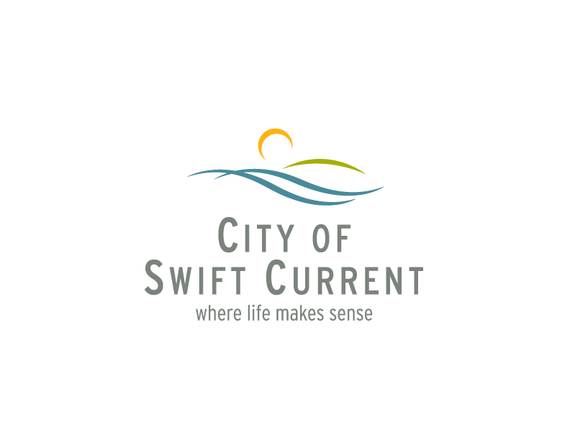 Swift Current, Sask.
July 25, 2022

Within the Council Chambers, City Hall, a regular meeting of the Council of the City of Swift Current was held on July 25, 2022 commencing at 6:30 p.m.

Attendance: Mayor A. Bridal
Councillor T. Christiansen
Councillor P. Friesen
Councillor R. Plewis
Councillor R. Switzer
Councillor L. Tuntland-Wiebe
Councillor J. Wall

Tim Marcus, CAO
Paul Hubbard, Acting General Manager of Corporate Services
Mitch Minken, General Manager of Infrastructure & Operations
Melissa Shaw, Acting General Manager of Community Services
Jackie Schlamp, City Clerk
Chrissy Carter, Interim Communications & Stakeholder Relations Coordinator
Jolene Peters, Manager of Engineering Services

Adoption of
Agenda.

No. 149 Moved by Councillor Christiansen, Seconded by Councillor Switzer:

"THAT the Agenda for the Council meeting of July 25, 2022 be adopted as circulated."

CARRIED.

Adoption of
Minutes.

No. 150 Moved by Councillor Friesen, Seconded by Councillor Wall:

“THAT the minutes of the regular Council meeting held June 27, 2022 be approved.”

CARRIED.
No. 151 Moved by Councillor Tuntland-Wiebe, Seconded by Councillor Plewis:

“THAT the minutes of the special Council meeting held July 13, 2022 be approved.”

CARRIED.

Proclamations.

Delegations.

Staff Sergeant Evan Gordon of the Swift Current City RCMP, attended to discuss RCMP issues.

Public
Hearings/
Notice
Matters.

Items for
Action.

Accounts. The General Revenue Fund Disbursement Records for the period of June 14 to June 28, 2022 were presented by the Acting General Manager of Corporate Services.

No. 152 Moved by Councillor Wall, Seconded by Councillor Christiansen:

"THAT the General Revenue Fund Disbursement Records for the period of June 14 to June 28, 2022 in the amount of $2,305,777.68 be approved."

CARRIED.

The General Revenue Fund Disbursement Records for the period of June 29 to July 11, 2022 were presented by the Acting General Manager of Corporate Services.

No. 153 Moved by Councillor Plewis, Seconded by Councillor Friesen:

"THAT the General Revenue Fund Disbursement Records for the period of June 29 to July 11, 2022 in the amount of $5,956,950.99 be approved."

CARRIED.

Urban A report regarding Urban Highway Connector Program Agreement was presented
Highway by the General Manager of Infrastructure and Operations.
Connector
Program.

No. 154 Moved by Councillor Friesen, Seconded by Councillor Tuntland-Wiebe:

“THAT Council approve the Urban Highway Connector Program Agreement and that the Mayor and Chief Administrative Officer be authorized to sign the said agreement.”

CARRIED.

Reports for
Information.

Bylaws.

No. 155 Moved by Councillor Plewis, Seconded by Councillor Christiansen:

1st Rdg “THAT Bill No. 6 – 2022 being a Borrowing Bylaw for financing within Utility Operations (2022 Capital Investments) be introduced and read a first time.”

CARRIED.

No. 156 Moved by Councillor Plewis, Seconded by Councillor Christiansen:

2nd Rdg “THAT Bill No. 6 – 2022 be taken as read a second time.”

CARRIED.

No. 157 Moved by Councillor Plewis, Seconded by Councillor Christiansen:

3rd Rdg “THAT Bill No. 6 – 2022 be given three readings at this meeting.”

CARRIED.

No. 158 Moved by Councillor Plewis, Seconded by Councillor Christiansen:

Final Rdg “THAT Bill No. 6 – 2022 be taken as read a third time and finally passed.”

CARRIED.

THIS BILL IS THEN NUMBERED BYLAW NO. 6 – 2022.

No. 159 Moved by Councillor Switzer, Seconded by Councillor Christiansen:

1st Rdg “THAT Bill No. 7 – 2022 being a Borrowing Bylaw for financing within Utility Operations (North Hill Reservoir Pump Station Upgrade) be introduced and read a first time.”

CARRIED.

No. 160 Moved by Councillor Switzer, Seconded by Councillor Christiansen:

2nd Rdg “THAT Bill No. 7 – 2022 be taken as read a second time.”

CARRIED.

No. 161 Moved by Councillor Switzer, Seconded by Councillor Christiansen:

3rd Rdg “THAT Bill No. 7 – 2022 be given three readings at this meeting.”

CARRIED.

No. 162 Moved by Councillor Switzer, Seconded by Councillor Christiansen:

Final Rdg “THAT Bill No. 7 – 2022 be taken as read a third time and finally passed.”

CARRIED.

THIS BILL IS THEN NUMBERED BYLAW NO. 7 – 2022.

Unfinished
Business.

New
Business.

No. 163 Moved by Councillor Switzer, Seconded by Councillor Wall:

“THAT the following be received as information and filed:

- Swift Current City Detachment Community Policing Report for June, 2022.”

CARRIED.

Communi-
cations.

En Camera
Items.

Reports of
Council
Members/
Enquiries.

The following topics were raised by members of Council:

- 11U 57’s Baseball Team Success;
- 15U 57’s AAA Baseball Team upcoming tournament;
- Thank you to City Staff for the prompt repair to Patterson Drive;
- Bicycle racks in the downtown core;
- U17 Sonic Softball team hosting of Provincials;
- Passing of Swift Current resident, Sammy Khalife, his passion and promoting the importance of organ donation;
- Swift Current Stock Car Association;
- Swift Current Chamber of Commerce, nominations now open for SCBEX awards; and
- City Staff member, Meghan Chisholm, participated in the 163km swim across Lake Diefenbaker to raise money for a women’s and children’s organization.

Adjourn-
ment.

No. 164 Moved by Councillor Christiansen, Seconded by Councillor Switzer:

(7:40 p.m.) “THAT we do now adjourn.”

CARRIED.

Mayor

City Clerk

